**Virtual environements:**

list environments: *conda env list*

*conda create -n env-name python=x.x anaconda*

ensuite:

*source activate env-name*

*source deactivate*

pour effacer:*conda env remove -n env-name*

**Link Jupyter with virtual kernels:** (https://github.com/Cadair/jupyter_environment_kernels)

To install the package that manages envs: *pip install environment_kernels*

To know your jupyter install: *jupyter --path*

To create a config file run: *jupyter notebook --generate-config*

To enable the plugin add the following line to your notebook:

*c.EnvironmentKernelSpecManager.env_dirs=['/home/juju/anaconda3/envs/']* # for ubuntu or Mac (*conda env list* to know the env paths)

*c.NotebookApp.kernel_spec_manager_class = 'environment_kernels.EnvironmentKernelSpecManager'*Furthermore remind to install ipython in all environments as it is the file what is looked for when finding available environments.

Julia with Jupyter: *apt-get install julia* ou *brew install [Caskroom/cask/?]julia*

In julia: *Pkg.update()*

*Pkg.add("IJulia")*

*using IJulia*

*notebook()*

The following may be useful: *git config --global url."https://".insteadOf git://*

Remark: A notebook that edits a lot of languages: http://beakernotebook.com/

**To install a package from source:**

*pip install .* # to install as a simple user

*pip install -e .* # to be able to develop

**PyCharm config**

**Add Header in PyCharm :**

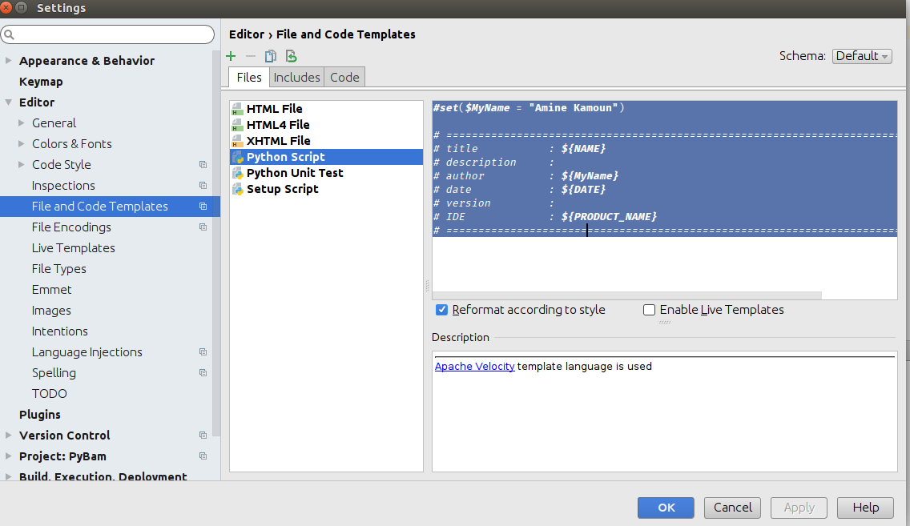

#set($MyName = "Amine Kamoun")

# ==============================================================================

# title : ${NAME}

# description :

# author : ${MyName}

# date : ${DATE}

# version :

# IDE : ${PRODUCT_NAME}

# ==============================================================================

**Disable PEP8 - E501**

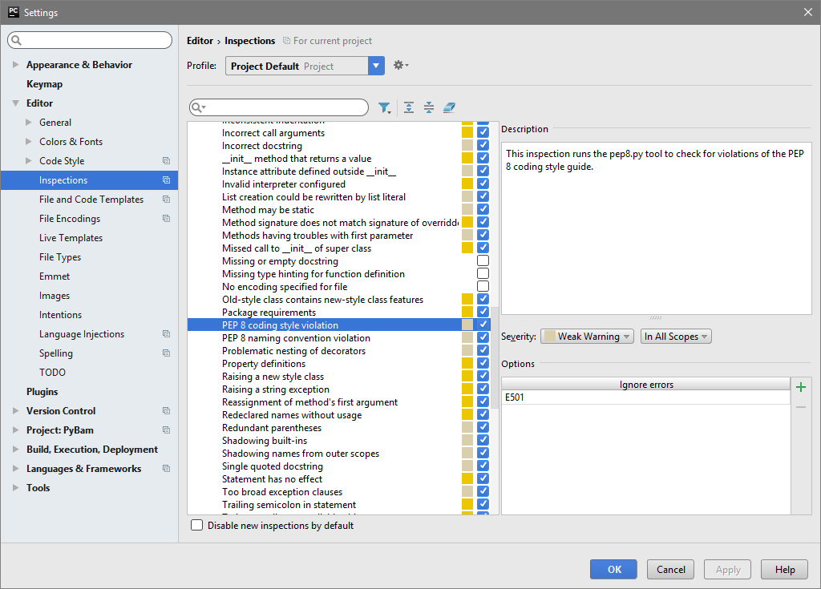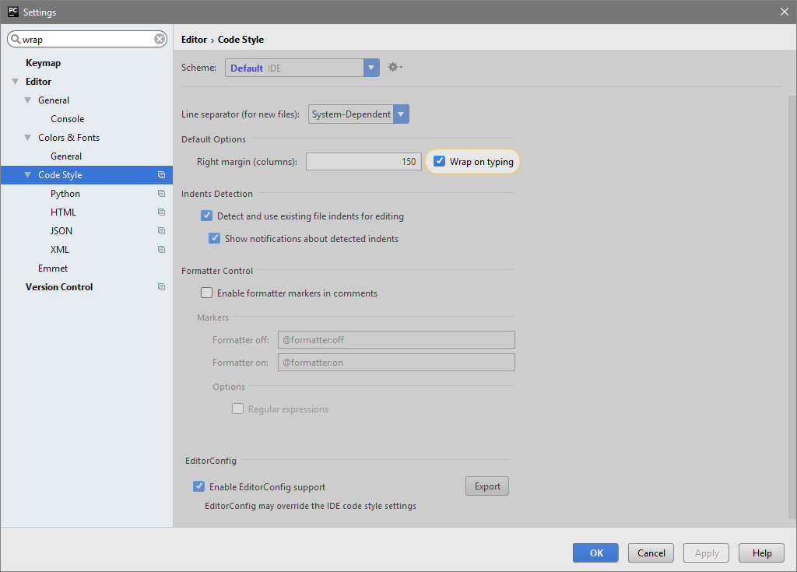The 79 character warning is particularly annoying. A reasonable limit you should enforce is 149 characters; you can set this in the editor.

**Setup your keymap**

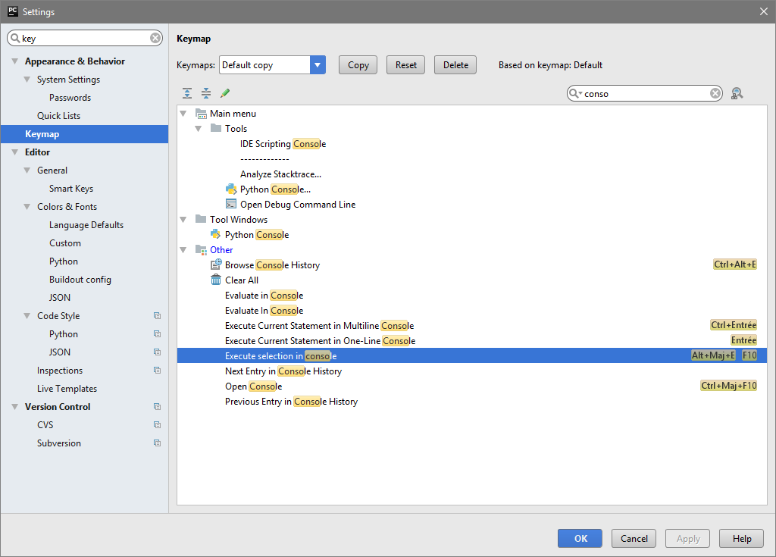

**PyCharm Plugins :**

* .ignore
* .idea